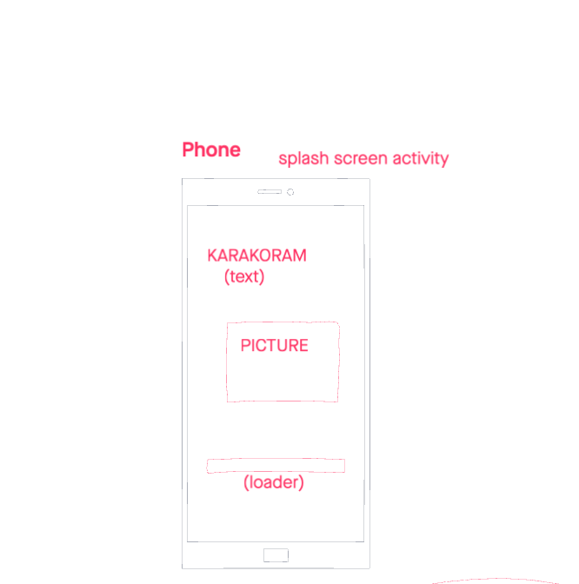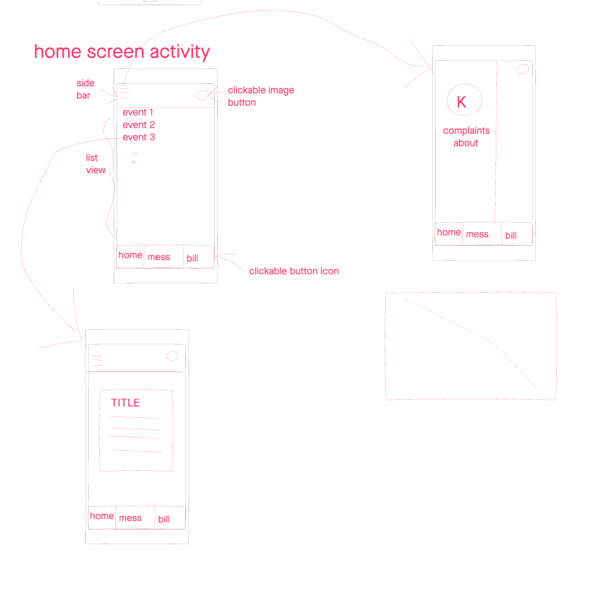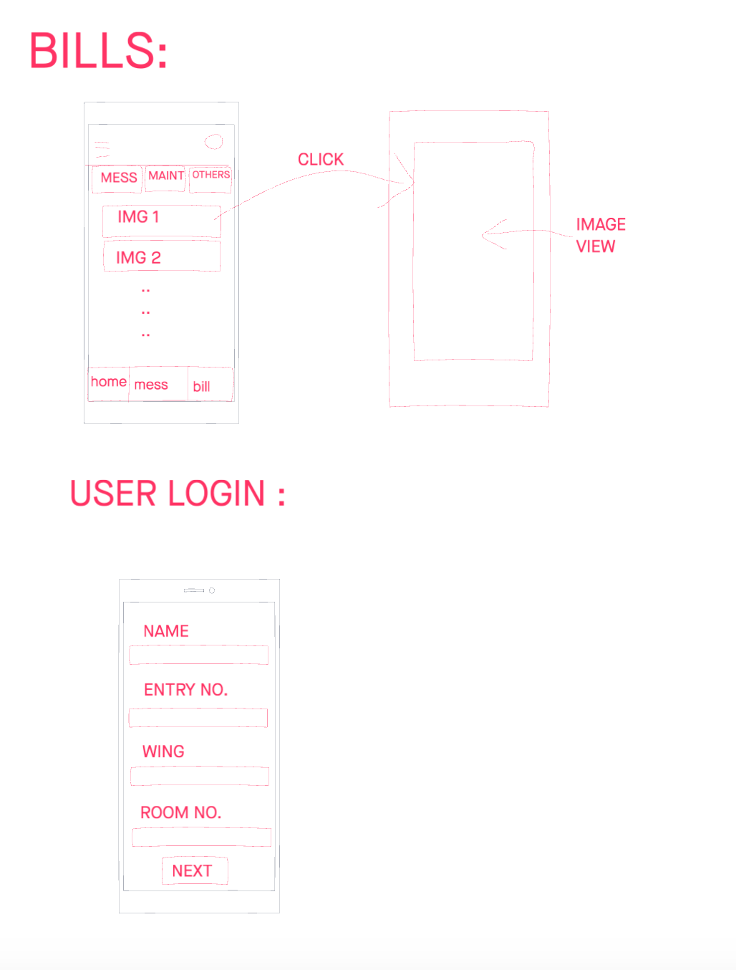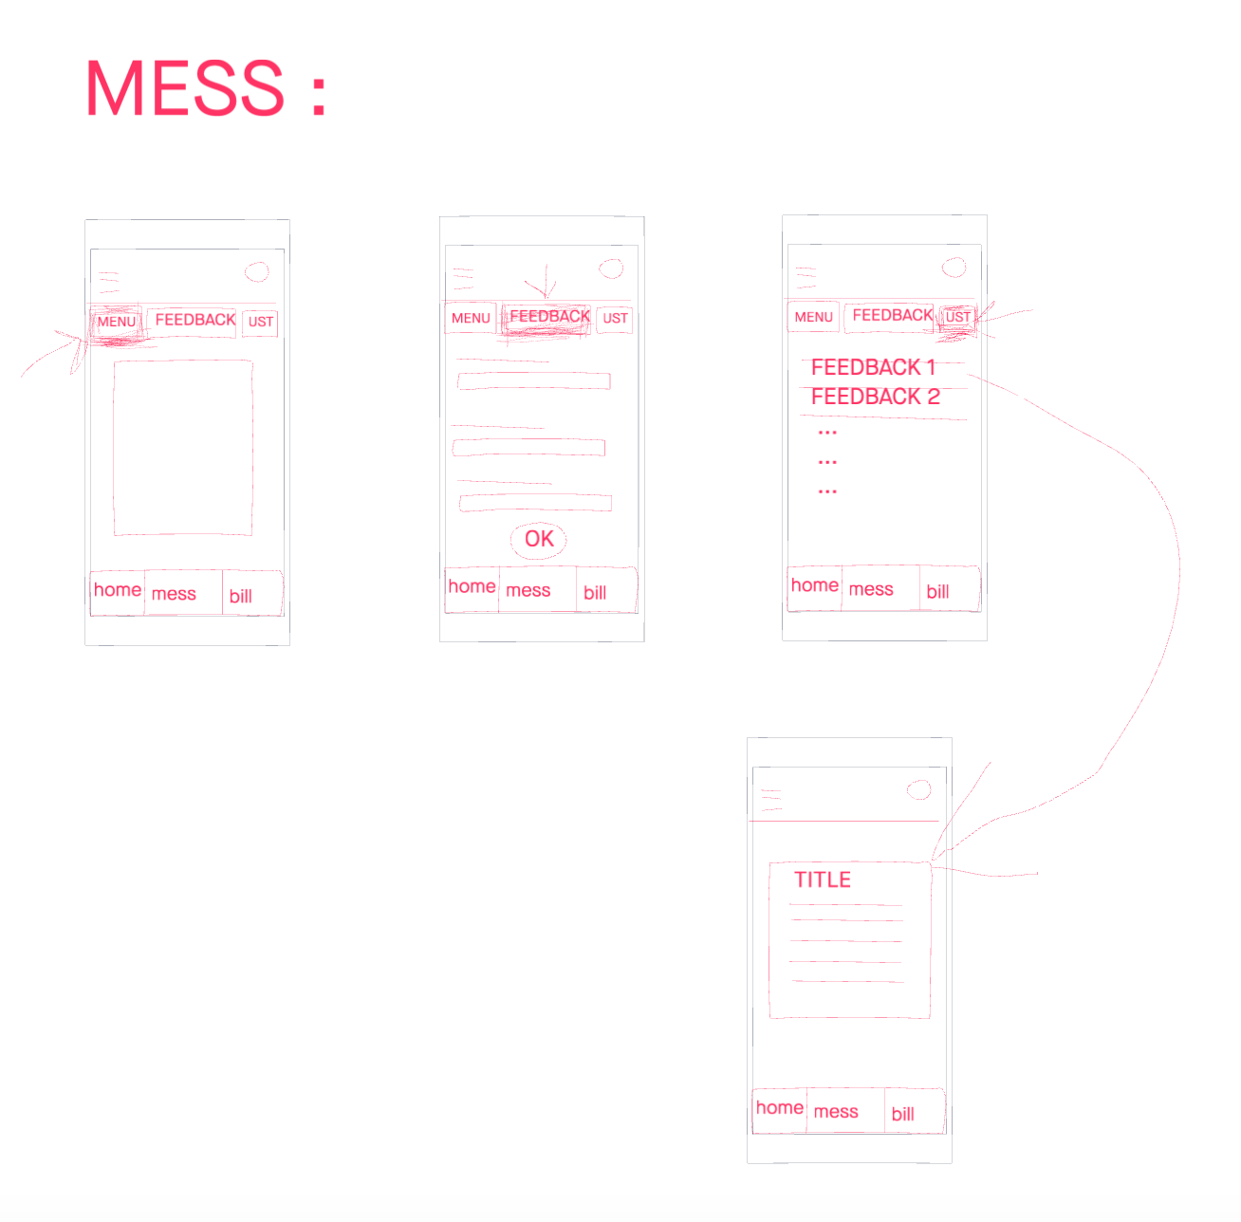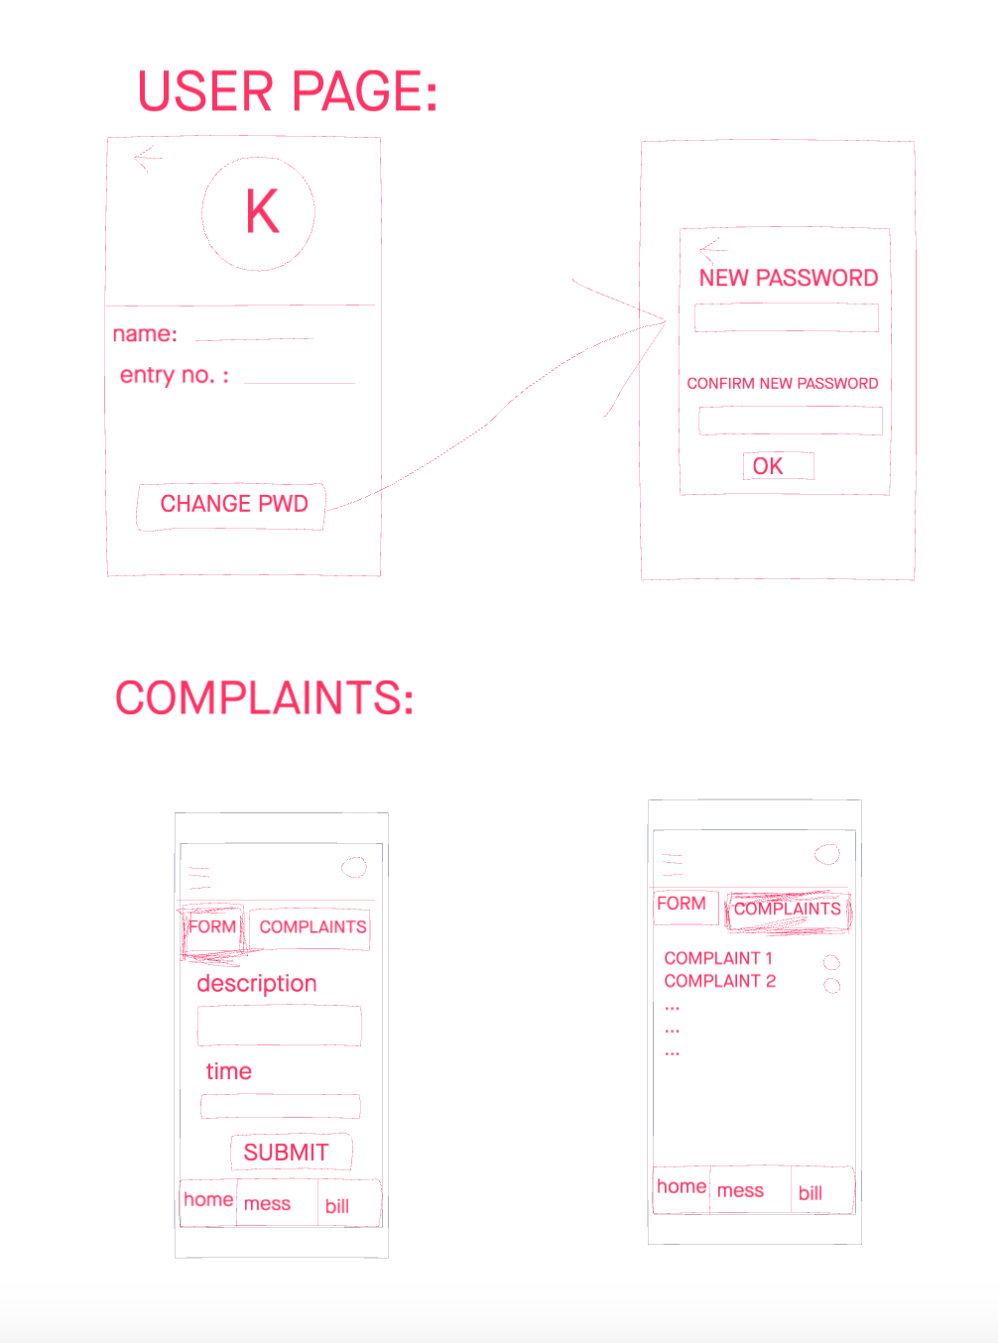

Comments:

1. We can add a page for *lost and found, complains* along with home,mess and bill
2. I’m not sure how we will create pages for every event as it comes up...maybe we can give some users admin privileges to add a new event (title, link, details etc..)
3. We can have an activity for fee structure in the bill page and a child activity for the users bills (due, paid etc..)